|  |  |
| --- | --- |
| MS5105 Exercise Number: | MS5105 Handup Exercise 2 |
| Student Number: | 19230487 |
| Student Name: | Jayakarthi Boovendran |
| Total Number of Pages: | 40 |

**Exercise Number: 5.2 – 02A**

**Dataset Used**: [DataSet1] C:\Users\Jaya Karthi Booven\Desktop\SPSS\Datasets\Ch 05 - Exercise 02A.sav

**Groups**

**G1** – Control Group (freshmen with no mentor)

**G2** – Mentor Group (freshman with In-person mentor)

**Hypotheses**

**H0**– There is no difference in grades of Control Group and Mentor Group (Null Hypotheses)

**H1** – Mentor Group had better overall grades than the Control Group

**Pretest Checklist for T-test**

Following are the pre-test conditions of T-test,

* Normality
* n quota
* Homogeneity of Variance

**Tests of Normality**

**Group 1- Control Group**

* **Histogram with Normal Curve**

DATASET NAME DataSet1 WINDOW=FRONT.

USE ALL.

COMPUTE filter_$=(group=1).

VARIABLE LABELS filter_$ 'group=1 (FILTER)'.

VALUE LABELS filter_$ 0 'Not Selected' 1 'Selected'.

FORMATS filter_$ (f1.0).

FILTER BY filter_$.

EXECUTE.

FREQUENCIES VARIABLES=enjoy

/FORMAT=NOTABLE

/HISTOGRAM NORMAL

/ORDER=ANALYSIS.

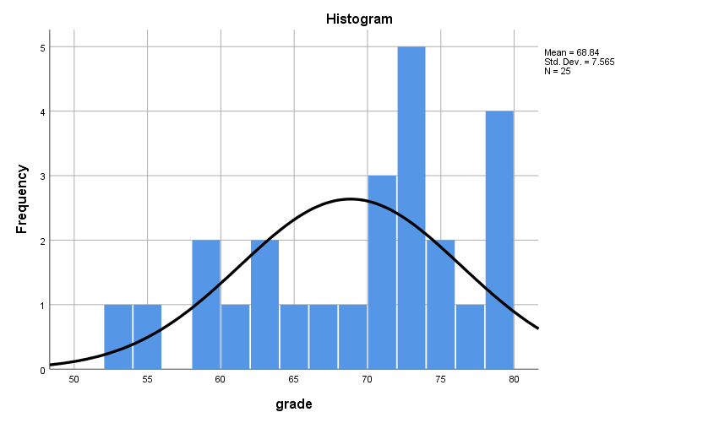

**Discussion**

From the visual interpretation of the historgram it is quite evident that grades are approximately normally distributed for Control Group (G1)

* **Shapiro-Wilk’s Test of Normality**

EXAMINE VARIABLES=grade BY filter_$

/PLOT BOXPLOT HISTOGRAM NPPLOT

/COMPARE GROUPS

/STATISTICS DESCRIPTIVES

/CINTERVAL 95

/MISSING LISTWISE

/NOTOTAL.

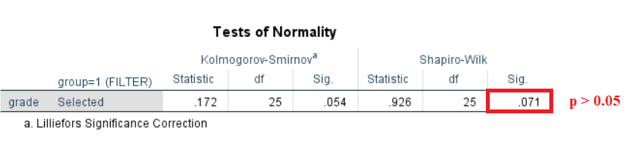

**Hypotheses**

Null Hypotheses – The sample distribution is normal

**Discussion**

Since the Shapiro-Wilk’s p>0.05, the Null Hypotheses is retained and the sample is assumed to be approximately normally distributed for Control Group (G1)

**Group 2 – Mentor Group**

* **Histogram with Normal Curve**

USE ALL.

COMPUTE filter_$=(group=2).

VARIABLE LABELS filter_$ 'group=2 (FILTER)'.

VALUE LABELS filter_$ 0 'Not Selected' 1 'Selected'.

FORMATS filter_$ (f1.0).

FILTER BY filter_$.

EXECUTE.

FREQUENCIES VARIABLES=grade

/FORMAT=NOTABLE

/HISTOGRAM NORMAL

/ORDER=ANALYSIS

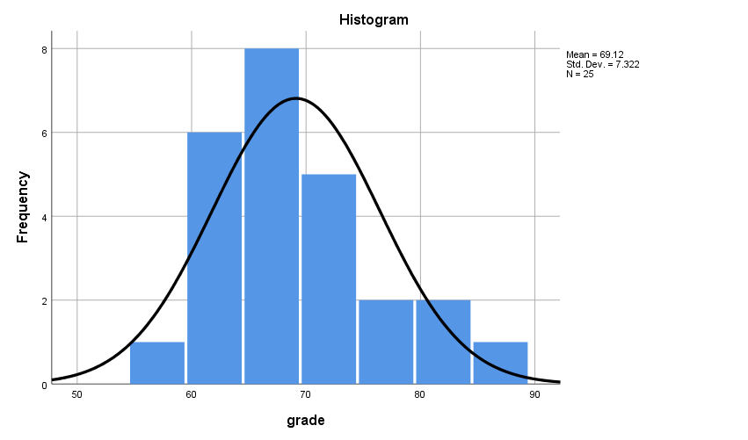

**Discussion**

From the visual interpretation of the historgram it is quite evident that grades are approximately normally distributed for Mentor Group (G2)

* **Shapiro-Wilk’s Test of Normality**

EXAMINE VARIABLES=grade BY filter_$

/PLOT BOXPLOT HISTOGRAM NPPLOT

/COMPARE GROUPS

/STATISTICS DESCRIPTIVES

/CINTERVAL 95

/MISSING LISTWISE

/NOTOTAL.

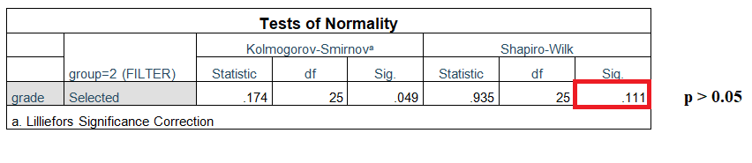

**Hypotheses**

Null Hypotheses – The sample distribution is normal

**Discussion**

Since p>0.05, the Null Hypotheses is retained and the sample is assumed to be approximately normally distributed for Mentor Group(G2)

**Discussion on Normality**

The **distribution of grades is reasonably normal for both the groups**. Thus, the pretest condition of Normality is met.

**Test for n-quota**

ONEWAY grade BY group

/STATISTICS DESCRIPTIVES HOMOGENEITY

/MISSING ANALYSIS.

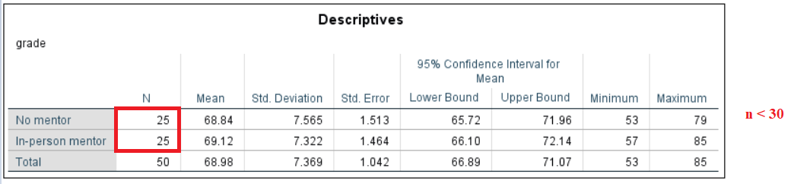

**Discussion**

Since the value of n is less than 30 for both the groups, the pretest condition of **n-quota is not met.**

**Test of Homogeneity of Variance**

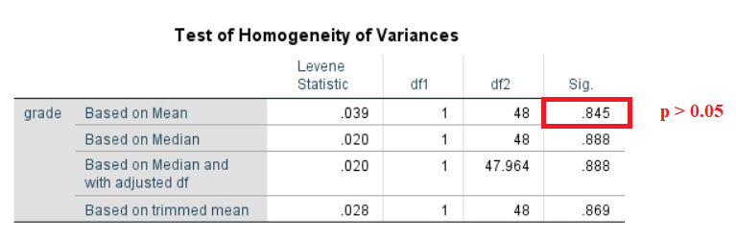

**Discussion**

The value of p > 0.05 suggests that there is no statistically significant difference between the variances of the groups. Hence, this **criterion is satisfied**.

**Petest Checklist for T-Test**

Below are the results of the pretests,

* Normality
* n – quota
* Homogeneity of Variance

**Discussion**

Since, one of the pretest conditions is not met; **Mann-Whitney** Test is performed instead of t-test.

**Mann-Whitney Test**

NPAR TESTS

/M-W= grade BY group(1 2)

/MISSING ANALYSIS.

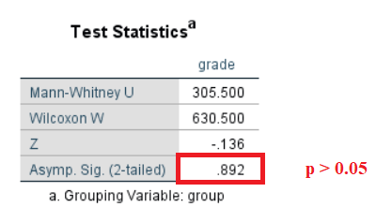

**Discussion**

The value of Mann-Whitney’s **P > 0.05** indicates that there is no statistical difference in grades of Control Group (G1) and Mentor Group (G2), hence, the **null hypothesis is retained**

**Hypotheses Resolution**

* **Accepted** => **H0**– There is no difference in grades of Control Group and Mentor Group (Null Hypotheses)
* **Rejected** => **H1** – Mentor Group had better overall grades than the Control Group

**Documenting Results**

Incoming freshman of the program are alternatively assigned to two groups, the mentor group and the control group. Freshman in the mentor group are assigned a mentor each and are asked to meet their mentors once every week for the entire term. However, the freshman under the control group has no such meetings. Both the groups are asked to submit academic transcripts by the end of the term.

Comparing the means of two groups, **µ(G1) : µ(G2)**

|  |  |
| --- | --- |
| Group | P |
| µ(Control Group)=68.84 : µ(Mentor Group)=69.12 | P=0.892 |

There was a difference of (µ=0.28) from between the groups. However, the test results of Mann-Whitney showed that there were **no significant statistical differences** (p=0.892, α=0.05) between the grades of freshmen of control group (µ=68.84, S.D=7.565) and freshmen of mentor group (µ=69.12, S.D=7.322)

Hence there is **no difference in the grades of Control Group and Mentor Group**

**Exercise Number:5.2 - 02B**

**Dataset Used**: [DataSet1] C:\Users\Jaya Karthi Booven\Desktop\SPSS\Datasets\Ch 05 - Exercise 02B.sav

**Groups**

G1 – Control Group (freshmen with no mentor)

G2 – Mentor Group (freshman with In-person mentor)

**Hypotheses**

H0 – There is no difference in grades of Control Group and Mentor Group (Null Hypotheses)

H1 – Mentor Group had better overall grades than the Control Group

**Pretest Checklist for T-test**

* Normality
* n quota
* Homogeneity of Variance

**Tests of Normality**

**Group 1**

* **Histogram with Normal Curve**

USE ALL.

COMPUTE filter_$=(group=1).

VARIABLE LABELS filter_$ 'group=1 (FILTER)'.

VALUE LABELS filter_$ 0 'Not Selected' 1 'Selected'.

FORMATS filter_$ (f1.0).

FILTER BY filter_$.

EXECUTE.

FREQUENCIES VARIABLES=grade

/FORMAT=NOTABLE

/HISTOGRAM NORMAL

/ORDER=ANALYSIS.

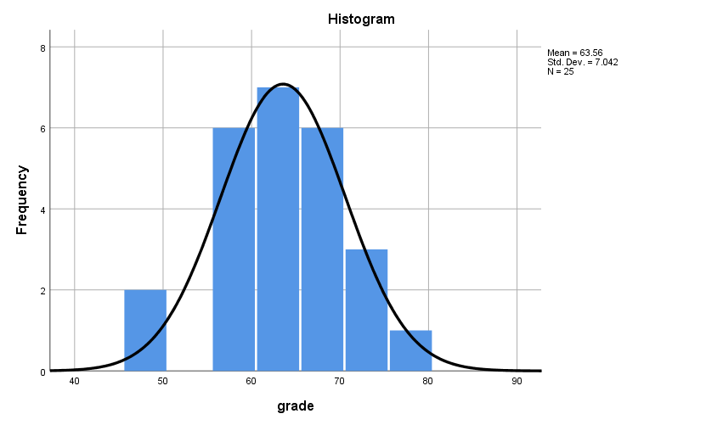

**Discussion**

The visual inspection of the histogram of G1 shows that the sample is approximately normally distributed

* **Shapiro-Wilk’s Test of Normality**

EXAMINE VARIABLES=grade BY filter_$

/PLOT BOXPLOT NPPLOT

/COMPARE GROUPS

/STATISTICS DESCRIPTIVES

/CINTERVAL 95

/MISSING LISTWISE

/NOTOTAL.

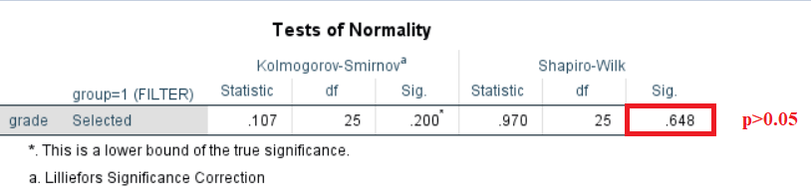

**Hypothesis**

Null Hypotheses – The sample distribution is normal (Null Hypotheses)

**Discussion**

Since the Shapiro-Wilk’s value of p > 0.05, the Null Hypotheses is retained and the sample is assumed to be approximately normally distributed

**Group 2**

* **Histogram with a normal curve**

USE ALL.

COMPUTE filter_$=(group=2).

VARIABLE LABELS filter_$ 'group=2 (FILTER)'.

VALUE LABELS filter_$ 0 'Not Selected' 1 'Selected'.

FORMATS filter_$ (f1.0).

FILTER BY filter_$.

EXECUTE.

FREQUENCIES VARIABLES=grade

/FORMAT=NOTABLE

/HISTOGRAM NORMAL

/ORDER=ANALYSIS.

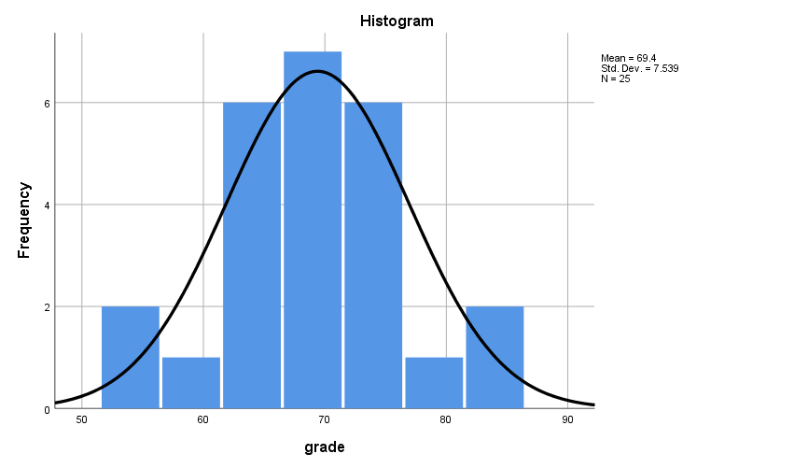

**Discusssion**

The visual inpection of the histogram proves that the sample of G2 is approximately normally distributed

* **Shapiro-Wilk’s Test of Normality**

EXAMINE VARIABLES=grade BY filter_$

/PLOT BOXPLOT NPPLOT

/COMPARE GROUPS

/STATISTICS DESCRIPTIVES

/CINTERVAL 95

/MISSING LISTWISE

/NOTOTAL.

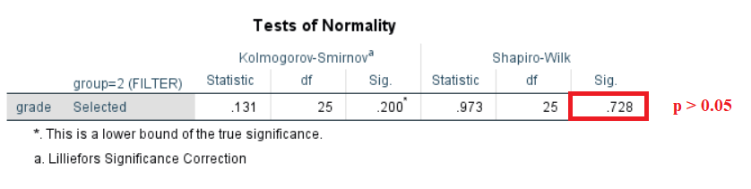

**Hypothesis**

Null Hypotheses – The sample distribution is normal (Null Hypotheses)

**Discussion**

Since the Shapiro-Wilk’s p>0.05, the Null Hypotheses is retained and the sample is assumed to be approximately normally distributed

**Documenting Results of Normality**

**Discussion**

The distribution of grades for both Group1 and Group2 is reasonably normal

**Test of n-quota**

ONEWAY grade BY group

/STATISTICS DESCRIPTIVES HOMOGENEITY

/MISSING ANALYSIS.

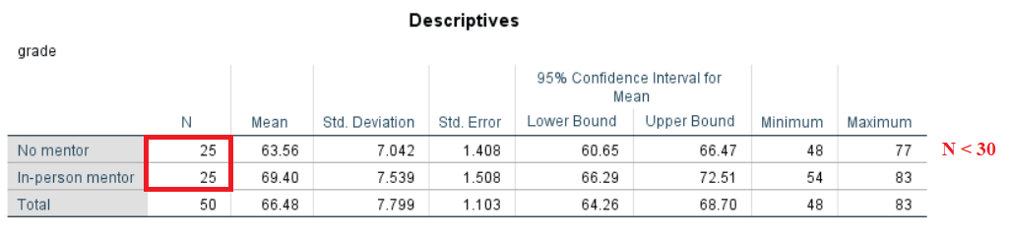

**Discussion**

Since the value of n is less than 30 for both the groups, the pretest condition of n-quota is not met.

**Test of Homogeneity of Variance**

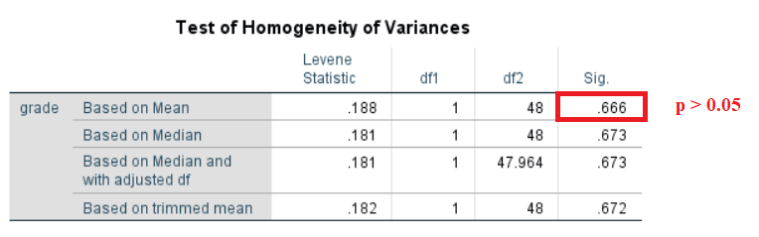

**Discussion**

The value of p > 0.05 suggests that there is no statistically significant difference between the variances. Hence, this criterion is satisfied.

**Petest Checklist for T-Test**

Below are the results of the pretests,

* Normality
* n – quota
* Homogeneity of Variance

**Discussion**

Since, one of the pretest conditions is not met; Mann-Whitney Test is performed instead of t-test.

**Mann-Whitney Test**

NPAR TESTS

/M-W= grade BY group(1 2)

/MISSING ANALYSIS.

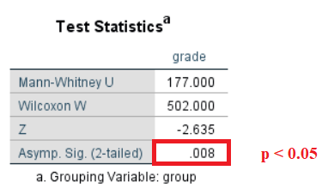

**Discussion**

**P < 0.05** indicates that there is a statistical difference in grades of Group1 and Group2, hence, the null hypothesis is rejected

**Hypotheses Resolution**

* **Rejected** => **H0**– There is no difference in grades of Control Group and Mentor Group (Null Hypotheses)
* **Accepted** => **H1** – Mentor Group had better overall grades than the Control Group

**Documenting Results**

Incoming freshman of the program are alternatively assigned to two groups, the mentor group and the control group. Freshman in the mentor group are assigned a mentor each and are asked to meet their mentors once every week for the entire term. However, the freshman under the control group has no such meetings. Both the groups are asked to submit academic transcripts by the end of the term.

Comparing the means of two groups,

**µ(G1) : µ(G2)**

|  |  |
| --- | --- |
| **Groups** | **P** |
| µ(Control Group)=63.56 : µ(Mentor Group)=69.40 | 0.008 |

**\*p<.05, ⸫ statistically significant difference**

Since the preconditions for the t-test is not met, we proceed with the Mann-Whitney test. There was a difference of (µ=5.86) from between the groups. However, the test results of Mann-Whitney showed that there were **a significant statistical differences** (p=0.008, α=0.05) between the grades of freshmen of control group (µ=63.56, S.D=7.042) and freshmen of mentor group (µ=69.40, S.D=7.539)

Hence it is evident that the **Mentor Group significantly outperformed the Control Group**.

**Exercise Number:5.4 - 04A**

**Dataset Used:** [DataSet1] C:\Users\Jaya Karthi Booven\Desktop\SPSS\Datasets\Ch 05 - Exercise 04A.sav

**Groups**

**G1**– Control Group (Regular Diet)

**G2** – Experimental Group (Regular Diet with Chocolate)

**Hypotheses**

**H0** – There is no difference between the moods of Control Group and Experimental Group (Null Hypotheses)

**H1**– Experimental Group shows better mood than Control Group

**Pretest Checklist for T-test**

Following are the pre-conditions of t-test,

* Normality
* n quota
* Homogeneity of Variance

**Tests of Normality**

**Group 1- Control Group**

* **Histogram with Normal Curve**

USE ALL.

COMPUTE filter_$=(group=1).

VARIABLE LABELS filter_$ 'group=1 (FILTER)'.

VALUE LABELS filter_$ 0 'Not Selected' 1 'Selected'.

FORMATS filter_$ (f1.0).

FILTER BY filter_$.

EXECUTE.

FREQUENCIES VARIABLES=mood

/FORMAT=NOTABLE

/HISTOGRAM NORMAL

/ORDER=ANALYSIS

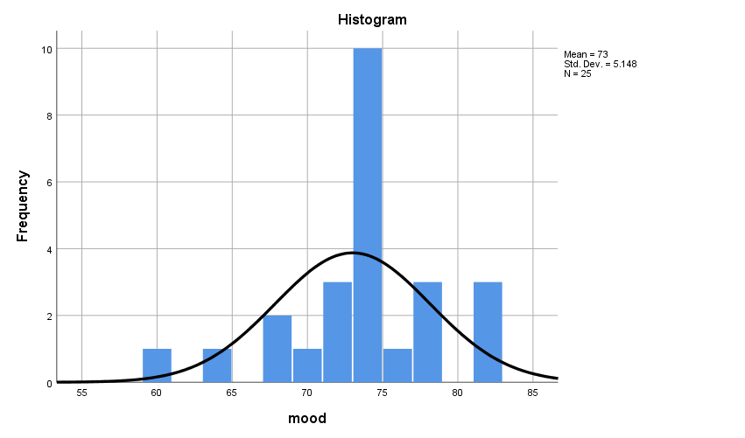

**Discussion**

From the visual interpretation of the histogram it is clear that the sample is approximately normally distributed and the curve is fairly symmetrical. Thus the assumption of normality is met.

* **Shapiro-Wilk’s Normality Test**

EXAMINE VARIABLES=mood BY filter_$

/PLOT BOXPLOT NPPLOT

/COMPARE GROUPS

/STATISTICS DESCRIPTIVES

/CINTERVAL 95

/MISSING LISTWISE

/NOTOTAL.

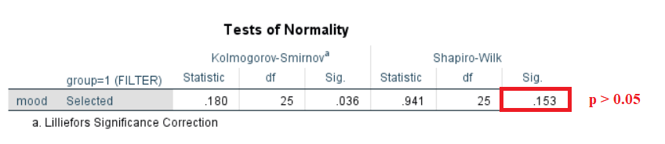

**Hypothesis**

Null Hypotheses – The sample distribution is normal (Null Hypotheses)

**Discussion**

The value of p=0.153 obtained from the Shapiro-Wilk’s test is greater than 0.05 (p>α). Hence, Null Hypotheses is retained and the sample is assumed to be approximately normally distributed

**Group 2- Experimental Group**

* **Histogram with a normal curve**

USE ALL.

COMPUTE filter_$=(group=2).

VARIABLE LABELS filter_$ 'group=2 (FILTER)'.

VALUE LABELS filter_$ 0 'Not Selected' 1 'Selected'.

FORMATS filter_$ (f1.0).

FILTER BY filter_$.

EXECUTE.

FREQUENCIES VARIABLES=mood

/FORMAT=NOTABLE

/HISTOGRAM NORMAL

/ORDER=ANALYSIS.

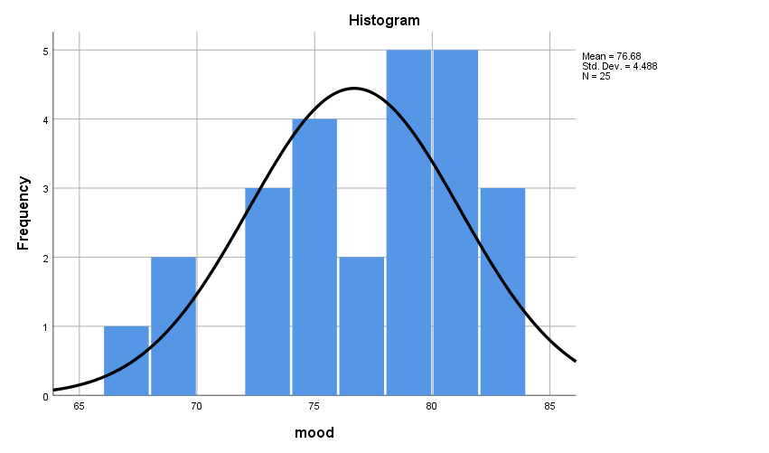

* **Shapiro-Wilk’s Normality Test**

EXAMINE VARIABLES=mood BY filter_$

/PLOT BOXPLOT NPPLOT

/COMPARE GROUPS

/STATISTICS DESCRIPTIVES

/CINTERVAL 95

/MISSING LISTWISE

/NOTOTAL.

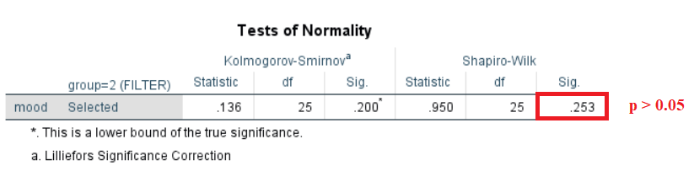

**Hypothesis**

Null Hypotheses – The sample distribution is normal (Null Hypotheses)

**Discussion**

The value of p=0.253 obtained from the Shapiro-Wilk’s test is greater than 0.05 (p>α). Hence, Null Hypotheses is retained and the sample is assumed to be approximately normally distributed

**Documenting Results of Normality**

**Discussion**

The distribution of mood is reasonably normal for both the Groups (G1 and G2). Hence the first pretest condition is met.

**Test for n - quota**

ONEWAY mood BY group

/STATISTICS DESCRIPTIVES HOMOGENEITY

/MISSING ANALYSIS.

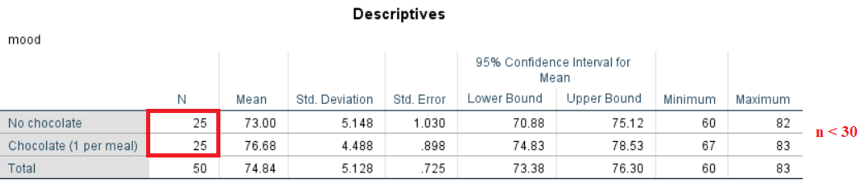

**Discussion**

The test for n-quota obtained a value of N < 30 for both the groups. Since the value of n is less than 30, the pre-test condition of n-quota is not met.

**Test of Homogeneity of Variance**

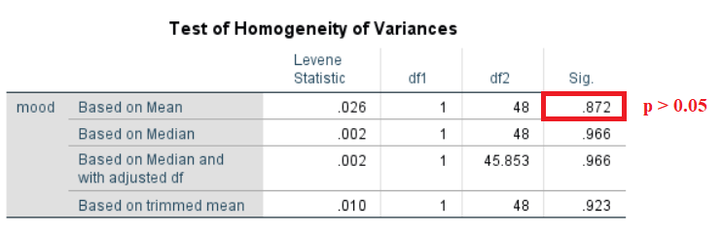

**Discussion**

The value of p>0.05 for the test of Homogeneity of Variance suggests that there is no statistically significant difference between the variances. Hence, this criterion is satisfied.

**Documenting Results of Pre-test Checklist of T-Test**

Below are the results of the pre-tests conditions,

* Normality
* n – quota
* Homogeneity of Variance

**Discussion**

Since, one of the pre-test conditions is not met; Mann-Whitney Test is performed instead of t-test.

**Mann-Whitney Test**

NPAR TESTS

/M-W= mood BY group(1 2)

/MISSING ANALYSIS

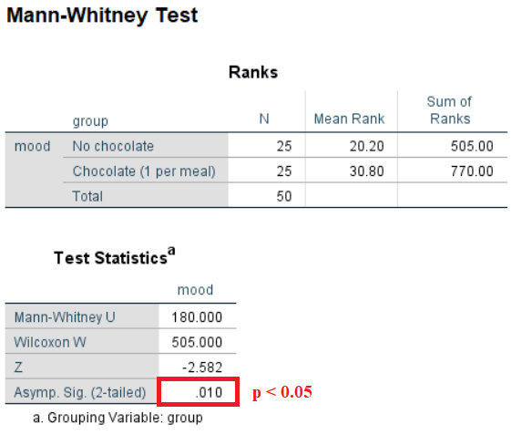

**Discussion**

**P < 0.05** indicates that there is a statistical difference in moods of Group1 and Group2. Hence, the null hypothesis is rejected

**Hypotheses Resolution**

* **Rejected => H0** – There is no difference between the moods of Control Group and Experimental Group (Null Hypotheses)
* **Accepted => H1**– Experimental Group shows better mood than Control Group

**Documenting Results**

Subjects are allotted to one of the two groups, the Control Group (**G1**) or the Experimental Group (**G2**). The Control group is instructed to follow a regular diet and the Experimental group is instructed take a piece of chocolate with every meal of the day. By the end of a week, both the groups are subjected to a mood test.

Comparing the means of moods of the two groups,

**µ(G1) : µ(G2)**

|  |  |
| --- | --- |
| **Groups** | **P** |
| µ(Control Group)=73.00 : µ(Experimental Group)=76.68 | 0.010 |

**\*p<.05, ⸫ statistically significant difference**

Since the preconditions for the t-test is not met, we proceed with the Mann-Whitney test. There is a significant difference in the mean (µ=3.68) between the groups. Furthermore, the test results of Mann-Whitney also confirmed that there were **a significant statistical differences** (p=0.010, α=0.05) between the moods of subjects of control group (µ=73.00, S.D=5.148) and moods of subjects belonging to the Experimental group (µ=76.68, S.D=4.488)

Hence it is evident that the **Experimental Group showed significantly better mood than the Control Group**.

**Exercise Number: 5.4 - 04B**

**Dataset Used:** [DataSet1] C:\Users\Jaya Karthi Booven\Desktop\SPSS\Datasets\Ch 05 - Exercise 04B.sav

**Groups**

**G1**– Control Group (Regular Diet)

**G2** – Experimental Group (Regular Diet with Chocolate)

**Hypotheses**

**H0** – There is no difference between the moods of Control Group and Experimental Group (Null Hypotheses)

**H1**– Experimental Group shows better mood than Control Group

**Pretest Checklist for T-test**

Following are the pre-conditions of t-test,

* Normality
* n quota
* Homogeneity of Variance

**Tests of Normality**

**Group1 – Control Group**

* **Histogram with Normal Curve**

USE ALL.

COMPUTE filter_$=(group=1).

VARIABLE LABELS filter_$ 'group=1 (FILTER)'.

VALUE LABELS filter_$ 0 'Not Selected' 1 'Selected'.

FORMATS filter_$ (f1.0).

FILTER BY filter_$.

EXECUTE.

FREQUENCIES VARIABLES=mood

/FORMAT=NOTABLE

/HISTOGRAM NORMAL

/ORDER=ANALYSIS

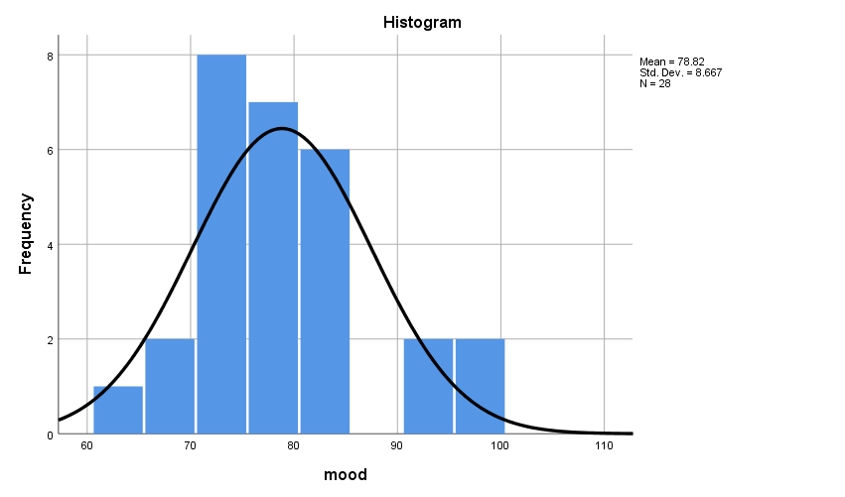

**Discussion**

From the visual interpretation of the histogram it is clear that the sample is approximately normally distributed and the curve is fairly symmetrical. Thus the assumption of normality is met.

* **Shapiro-Wilk’s Normality Test**

EXAMINE VARIABLES=mood BY filter_$

/PLOT BOXPLOT NPPLOT

/COMPARE GROUPS

/STATISTICS DESCRIPTIVES

/CINTERVAL 95

/MISSING LISTWISE

/NOTOTAL.

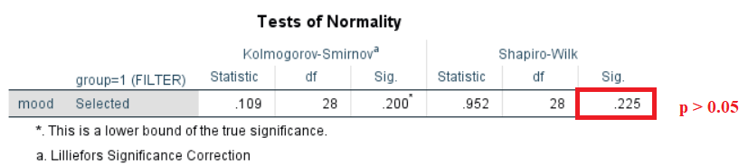

**Hypothesis**

Null Hypotheses – The sample distribution is normal (Null Hypotheses)

**Discussion**

The value of p=0.225 obtained from the Shapiro-Wilk’s test is greater than 0.05 (p>α). Hence, Null Hypotheses is retained and the sample is assumed to be approximately normally distributed

**Group 2 – Experimental Group**

* **Histogram with a normal curve**

USE ALL.

COMPUTE filter_$=(group=2).

VARIABLE LABELS filter_$ 'group=2 (FILTER)'.

VALUE LABELS filter_$ 0 'Not Selected' 1 'Selected'.

FORMATS filter_$ (f1.0).

FILTER BY filter_$.

EXECUTE.

FREQUENCIES VARIABLES=mood

/FORMAT=NOTABLE

/HISTOGRAM NORMAL

/ORDER=ANALYSIS.

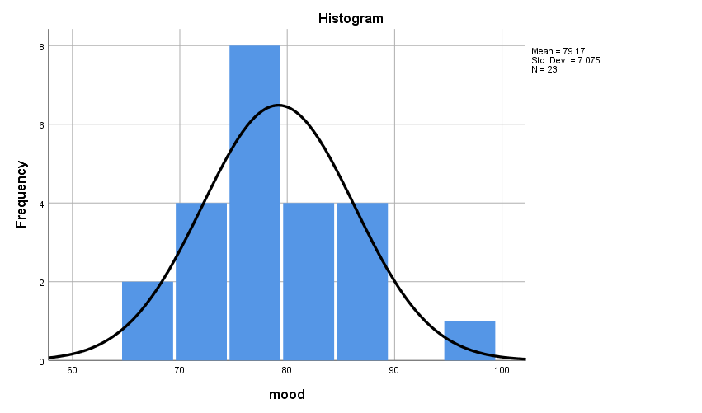

**Discussion**

From the visual interpretation of the histogram it is clear that the sample is approximately normally distributed and the curve is fairly symmetrical. Thus the assumption of normality is met.

* **Shapiro-Wilk’s Normality Test**

EXAMINE VARIABLES=mood BY filter_$

/PLOT BOXPLOT NPPLOT

/COMPARE GROUPS

/STATISTICS DESCRIPTIVES

/CINTERVAL 95

/MISSING LISTWISE

/NOTOTAL.

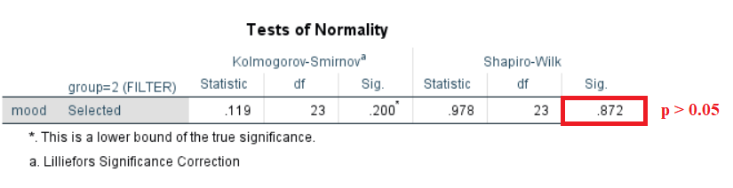

**Hypothesis**

Null Hypotheses – The sample distribution is normal (Null Hypotheses)

**Discussion**

The value of **p=0.872** obtained from the Shapiro-Wilk’s test is greater than 0.05 (p>α). Hence, Null Hypotheses is retained and the sample is assumed to be approximately normally distributed

**Documenting Results of Normality**

**Discussion**

The distribution of mood is **reasonably normal** for both the Groups (G1 and G2). Hence the first pretest condition is met.

**Test for n - quota**

ONEWAY mood BY group

/STATISTICS DESCRIPTIVES HOMOGENEITY

/MISSING ANALYSIS.

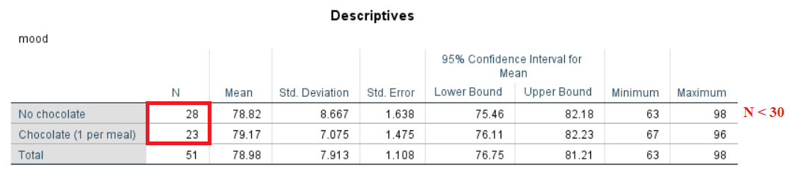

**Discussion**

The test for n-quota obtained a value of N < 30 for both the groups. Since the value of n is less than 30, the pretest condition of n-quota is not met.

**Test of Homogeneity of Variance**

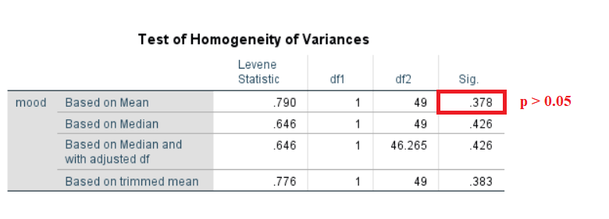

**Discussion**

The value of p>0.05 for the test of Homogeneity of Variance suggests that there is no statistically significant difference between the variances. Hence, this criterion is satisfied.

**Documenting Results of Pretest Checklist of T-Test**

Below are the results of the pre-test conditions,

* Normality
* n – quota
* Homogeneity of Variance

**Discussion**

Since, one of the pre-test conditions is not met; Mann-Whitney Test is performed instead of t-test.

**Mann-Whitney Test**

NPAR TESTS

/M-W= mood BY group(1 2)

/MISSING ANALYSIS

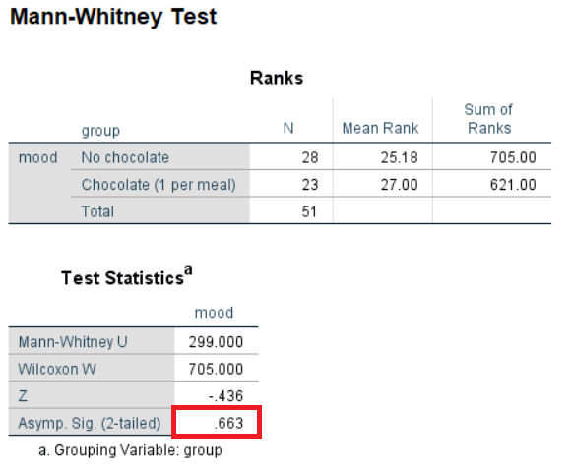

**Discussion**

**P > 0.05** indicates that there is no statistical difference in moods of Group1 and Group2. Hence, the null hypothesis is rejected

**Hypotheses Resolution**

* **Accepted => H0** – There is no difference between the moods of Control Group and Experimental Group (Null Hypotheses)
* **Rejected => H1**– Experimental Group shows better mood than Control Group

**Documenting Results**

Subjects are allotted to one of the two groups, the Control Group (**G1**) or the Experimental Group (**G2**). The Control group is instructed to follow a regular diet and the Experimental group is instructed take a piece of chocolate with every meal of the day. By the end of a week, both the groups are subjected to a mood test.

Comparing the means of moods of the two groups,

**µ(G1) : µ(G2)**

|  |  |
| --- | --- |
| **Groups** | **P** |
| µ(Control Group)=78.82 : µ(Experimental Group)=79.17 | 0.663 |

**\*p>.05, ⸫ no statistically significant difference**

Since the preconditions for the t-test is not met, we proceed with the Mann-Whitney test. There is a slight difference in the mean (µ=0.35) between the groups. However, the test results of Mann-Whitney also confirmed that there were **no significant statistical differences** (p=0.663, α=0.05) between the moods of subjects of control group (µ=78.82, S.D=8.667) and moods of subjects belonging to the Experimental group (µ=79.17, S.D=7.075)

Hence it is evident that the there is **no difference in the moods of Experimental Group and Control Group**.

**Exercise Number: 5.6 – 06A**

**Dataset Used:** [DataSet1] C:\Users\Jaya Karthi Booven\Desktop\SPSS\Datasets\Ch 05 - Exercise 06A.sav

**Groups**

**G1**– Control Group (Video with no laugh track)

**G2** – Treatment Group (Video with laugh track)

**Hypotheses**

**H0** – There is no difference in the enjoyment level of Control Group (**G1)** and Treatment Group (**G2)** (Null Hypotheses)

**H1**– Treatment Group (**G2)** enjoyed the video more than the Control Group (**G1)**

**Pretest Checklist for T-test**

Following are the pre-conditions of t-test,

* Normality
* n quota
* Homogeneity of Variance

**Tests of Normality**

**Group 1 – Control Group**

* **Histogram with Normal Curve**

USE ALL.

COMPUTE filter_$=(group=1).

VARIABLE LABELS filter_$ 'group=1 (FILTER)'.

VALUE LABELS filter_$ 0 'Not Selected' 1 'Selected'.

FORMATS filter_$ (f1.0).

FILTER BY filter_$.

EXECUTE.

FREQUENCIES VARIABLES=enjoy

/FORMAT=NOTABLE

/HISTOGRAM NORMAL

/ORDER=ANALYSIS.

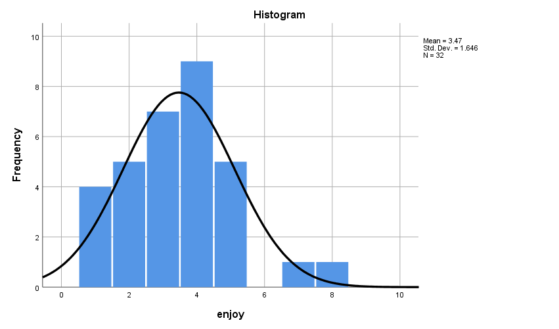

**Discussion**

From the visual interpretation of the histogram it is clear that the sample is approximately normally distributed and the curve is fairly symmetrical. Thus the assumption of normality is met.

* **Shapiro-Wilk’s Normality Test**

EXAMINE VARIABLES=enjoy BY filter_$

/PLOT BOXPLOT NPPLOT

/COMPARE GROUPS

/STATISTICS DESCRIPTIVES

/CINTERVAL 95

/MISSING LISTWISE

/NOTOTAL.

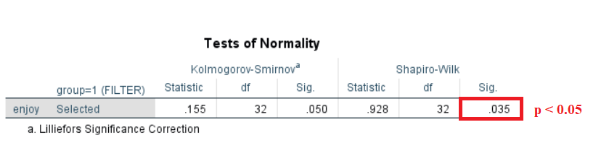

**Hypothesis**

Null Hypotheses – The sample distribution is normal (Null Hypotheses)

**Discussion**

The value of p=0.035 obtained from the Shapiro-Wilk’s test is less than 0.05 (p<α). Hence, Null Hypotheses is rejected and the sample is assumed to be **not normally distributed**

**Group 2 – Treatment Group**

* **Histogram with a normal curve**

USE ALL.

COMPUTE filter_$=(group=2).

VARIABLE LABELS filter_$ 'group=2 (FILTER)'.

VALUE LABELS filter_$ 0 'Not Selected' 1 'Selected'.

FORMATS filter_$ (f1.0).

FILTER BY filter_$.

EXECUTE.

FREQUENCIES VARIABLES=enjoy

/FORMAT=NOTABLE

/HISTOGRAM NORMAL

/ORDER=ANALYSIS.

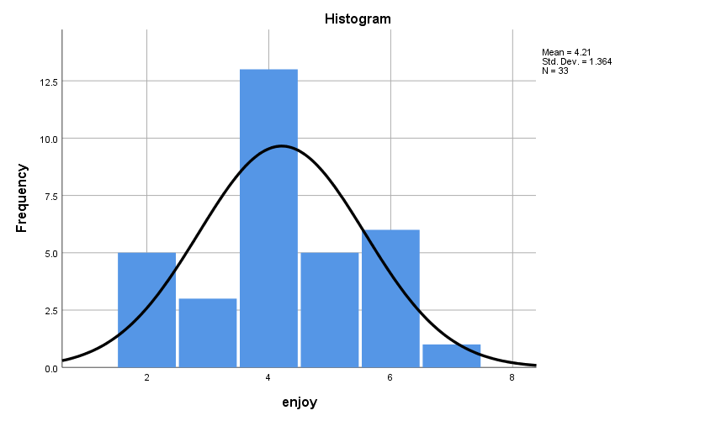

**Discussion**

From the visual interpretation of the histogram it is clear that the sample is approximately normally distributed and the curve is fairly symmetrical. Thus the assumption of normality is met.

* **Shapiro-Wilk’s Normality Test**

EXAMINE VARIABLES=enjoy BY filter_$

/PLOT BOXPLOT NPPLOT

/COMPARE GROUPS

/STATISTICS DESCRIPTIVES

/CINTERVAL 95

/MISSING LISTWISE

/NOTOTAL.

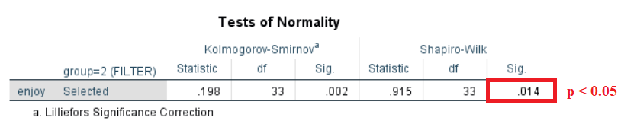

**Hypothesis**

Null Hypotheses – The sample distribution is normal (Null Hypotheses)

**Discussion**

The value of p=0.014 obtained from the Shapiro-Wilk’s test is less than 0.05 (p<α). Hence, Null Hypotheses is rejected and the sample is assumed to be **not normally distributed**

**Documenting Results of Normality**

**Discussion**

The distribution of samples for both the Groups (G1 and G2) is not normally distributed. Hence the **pretest condition of Normality is not met**.

**Test for n - quota**

ONEWAY enjoy BY group

/STATISTICS DESCRIPTIVES HOMOGENEITY

/MISSING ANALYSIS.

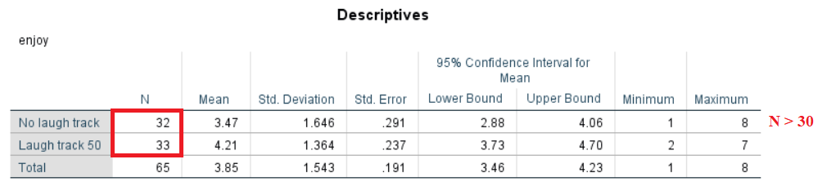

**Discussion**

The test for n-quota obtained a value of N > 30 for both the groups. Hence, the **pre-test condition of n-quota is met**.

**Test of Homogeneity of Variance**

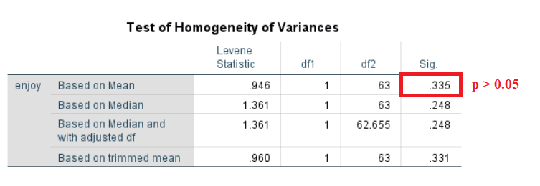

**Discussion**

The value of p>0.05 for the test of Homogeneity of Variance suggests that there is no statistically significant difference between the variances. Hence, this criterion is satisfied.

**Documenting Results of Pre-test Checklist of T-Test**

Below are the results of the pre-test conditions,

* Normality
* n – quota
* Homogeneity of Variance

**Discussion**

Since, not all of the pre-test conditions are met; Mann-Whitney Test is performed instead of t-test.

**Mann-Whitney Test**

NPAR TESTS

/M-W= enjoy BY group(1 2)

/MISSING ANALYSIS.

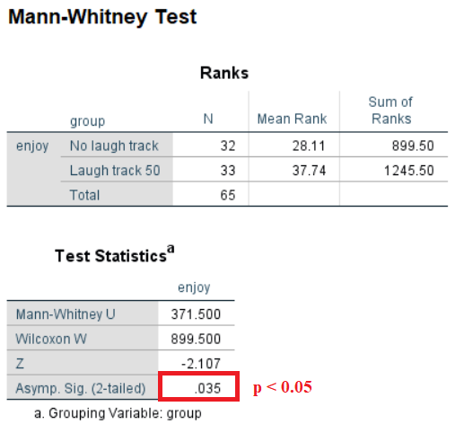

**Discussion**

**P < 0.05** indicates that there is a statistical difference between of Group1 and Group2. Hence, the null hypothesis is rejected

**Hypotheses Resolution**

* **Rejected => H0** – There is no difference in the enjoyment level of Control Group (**G1)** and Treatment Group (**G2)** (Null Hypotheses)
* **Accepted => H1**– Treatment Group (**G2)** enjoyed the comedy video more than the Control Group (**G1)**

**Documenting Results**

Subjects are allotted to one of the two groups, the Control Group (**G1**) or the Treatment Group (**G2**). The Control group is instructed to watch a video with no laugh track and the Experimental group is instructed to watch the same video but with laugh track on. By the end of the video, both the groups are subjected to report their level of enjoyment while watching the video on a scale of 1 to 5.

Comparing the means of enjoyment level of the two groups,

**µ(G1) : µ(G2)**

|  |  |
| --- | --- |
| **Groups** | **P** |
| µ(Control Group)=3.47 : µ(Treatment Group)=4.21 | 0.035 |

**\*p<.05, ⸫ statistically significant difference**

Since not all the preconditions for the t-test are met, we proceed with the Mann-Whitney test. There is a slight difference in the mean (µ=0.13) between the groups. Furthermore, the test results of Mann-Whitney confirms that there is **a** **significant statistical difference** (p=0.035, α=0.05) between the level of enjoyment among subjects of control group (µ=3.47, S.D=1.646) and subjects belonging to the Treatment group (µ=4.21, S.D=1.364)

Hence it is evident that there is **a statistically significant difference** in the level of enjoyment between the Control Group **(G1)** and the Treatment Group **(G2)**, where the **Treatment group significantly outperformed the Control Group**.

**Exercise Number: 5.6 – 06B**

**Dataset Used:** [DataSet1] C:\Users\Jaya Karthi Booven\Desktop\SPSS\Datasets\Ch 05 - Exercise 06B.sav

**Groups**

**G1**– Control Group (Video with no laugh track)

**G2** – Treatment Group (Video with laugh track)

**Hypotheses**

**H0** – There is no difference in the enjoyment level of Control Group (**G1)** and Treatment Group (**G2)** (Null Hypotheses)

**H1**– Treatment Group (**G2)** enjoyed the video more than the Control Group (**G1)**

**Pretest Checklist for T-test**

Following are the pre-conditions of t-test,

* Normality
* n quota
* Homogeneity of Variance

**Tests of Normality**

**Group 1 – Control Group**

* **Histogram with Normal Curve**

USE ALL.

COMPUTE filter_$=(group=1).

VARIABLE LABELS filter_$ 'group=1 (FILTER)'.

VALUE LABELS filter_$ 0 'Not Selected' 1 'Selected'.

FORMATS filter_$ (f1.0).

FILTER BY filter_$.

EXECUTE.

FREQUENCIES VARIABLES=enjoy

/FORMAT=NOTABLE

/HISTOGRAM NORMAL

/ORDER=ANALYSIS. 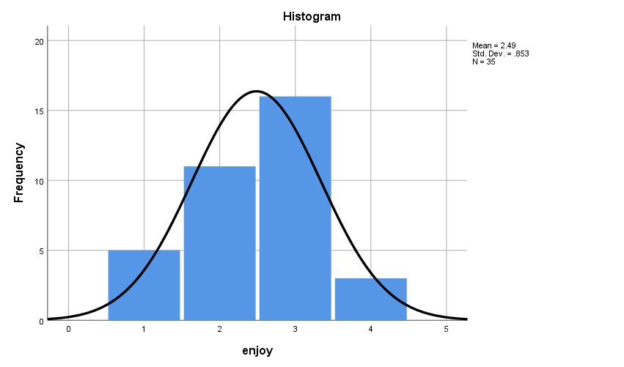

**Discussion**

From the visual interpretation of the histogram it is clear that the sample is approximately normally distributed and the curve is fairly symmetrical. Thus the assumption of normality is met.

* **Shapiro-Wilk’s Normality Test**

EXAMINE VARIABLES=enjoy BY filter_$

/PLOT BOXPLOT NPPLOT

/COMPARE GROUPS

/STATISTICS DESCRIPTIVES

/CINTERVAL 95

/MISSING LISTWISE

/NOTOTAL.

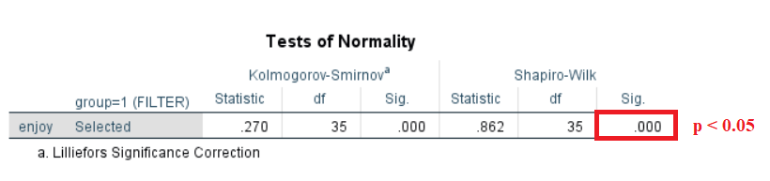

**Hypothesis**

Null Hypotheses – The sample distribution is normal (Null Hypotheses)

**Discussion**

The value of p=0.000 obtained from the Shapiro-Wilk’s test is less than 0.05 (p<α). Hence, Null Hypotheses is rejected and the sample is assumed to be **not normally distributed**

**Group 2 – Treatment Group**

* **Histogram with a normal curve**

USE ALL.

COMPUTE filter_$=(group=2).

VARIABLE LABELS filter_$ 'group=2 (FILTER)'.

VALUE LABELS filter_$ 0 'Not Selected' 1 'Selected'.

FORMATS filter_$ (f1.0).

FILTER BY filter_$.

EXECUTE.

FREQUENCIES VARIABLES=enjoy

/FORMAT=NOTABLE

/HISTOGRAM NORMAL

/ORDER=ANALYSIS.

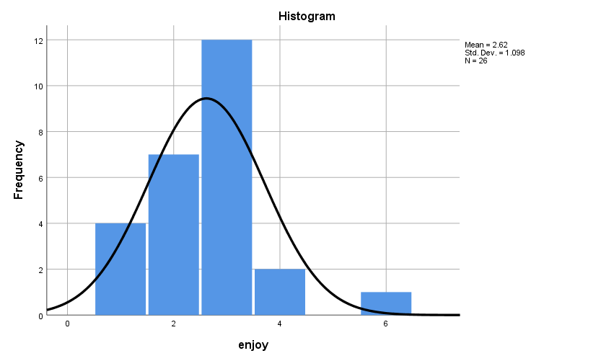

**Discussion**

From the visual interpretation of the histogram it is clear that the sample is approximately normally distributed and the curve is fairly symmetrical. Thus the assumption of normality is met.

* **Shapiro-Wilk’s Normality Test**

EXAMINE VARIABLES=enjoy BY filter_$

/PLOT BOXPLOT NPPLOT

/COMPARE GROUPS

/STATISTICS DESCRIPTIVES

/CINTERVAL 95

/MISSING LISTWISE

/NOTOTAL.

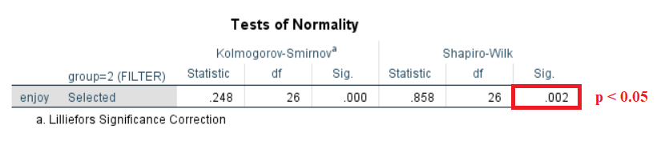

**Hypothesis**

Null Hypotheses – The sample distribution is normal (Null Hypotheses)

**Discussion**

The value of p=0.002 obtained from the Shapiro-Wilk’s test is less than 0.05 (p<α). Hence, Null Hypotheses is rejected and the sample is assumed to be **not normally distributed**

**Documenting Results of Normality**

**Discussion**

The distribution of samples for both the Groups (G1 and G2) is not normally distributed. Hence the **pretest condition of Normality is not met**.

**Test for n - quota**

ONEWAY enjoy BY group

/STATISTICS DESCRIPTIVES HOMOGENEITY

/MISSING ANALYSIS.

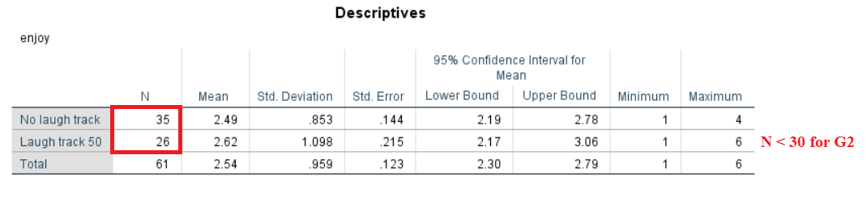

**Discussion**

The test for n-quota obtained a value of N < 30 for one of the groups. Since the value of n is less than 30, the **pre-test condition of n-quota is not met**.

**Test of Homogeneity of Variance**

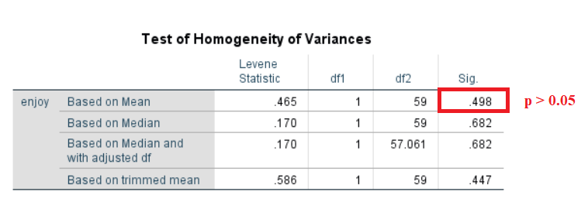

**Discussion**

The value of p>0.05 for the test of Homogeneity of Variance suggests that there is no statistically significant difference between the variances. Hence, this criterion is satisfied.

**Documenting Results of Pre-test Checklist of T-Test**

Below are the results of the pre-test conditions,

* Normality
* n – quota
* Homogeneity of Variance

**Discussion**

Since, not all of the pre-test conditions are met; Mann-Whitney Test is performed instead of t-test.

**Mann-Whitney Test**

NPAR TESTS

/M-W= enjoy BY group(1 2)

/MISSING ANALYSIS.

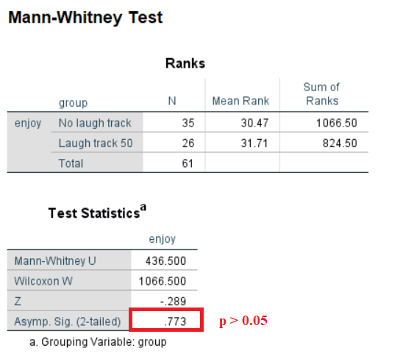

**Discussion**

**P > 0.05** indicates that there is no statistical difference between of Group1 and Group2. Hence, the null hypothesis is accepted

**Hypotheses Resolution**

* **Accepted => H0** – There is no difference in the enjoyment level of Control Group (**G1)** and Treatment Group (**G2)** (Null Hypotheses)
* **Rejected => H1**– Treatment Group (**G2)** enjoyed the comedy video more than the Control Group (**G1)**

**Documenting Results**

Subjects are allotted to one of the two groups, the Control Group (**G1**) or the Treatment Group (**G2**). The Control group is instructed to watch a video with no laugh track and the Experimental group is instructed to watch the same video but with laugh track on. By the end of the video, both the groups are subjected to report their level of enjoyment while watching the video on a scale of 1 to 5.

Comparing the means of enjoyment level of the two groups,

**µ(G1) : µ(G2)**

|  |  |
| --- | --- |
| **Groups** | **P** |
| µ(Control Group)=2.49 : µ(Treatment Group)=2.62 | 0.773 |

**\*p>.05, ⸫ there is no statistically significant difference**

Since not all the preconditions for the t-test are met, we proceed with the Mann-Whitney test. There is a slight difference in the mean (µ=0.13) between the groups. However, the test results of Mann-Whitney confirms that there is **no** **significant statistical differences** (p=0.773, α=0.05) between the level of enjoyment among subjects of control group (µ=2.49, S.D=0.853) and subjects belonging to the Treatment group (µ=2.62, S.D=1.098)

Hence it is evident that the **No Statistically significant difference** in the level of enjoyment between the Control Group **(G1)** and the Treatment Group **(G2)**.